CIS 2109 Lab 7

10/24/2018

Scott O’Hara

**Part 1**

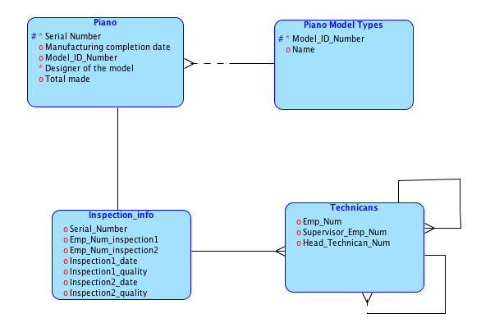

**Part 2**

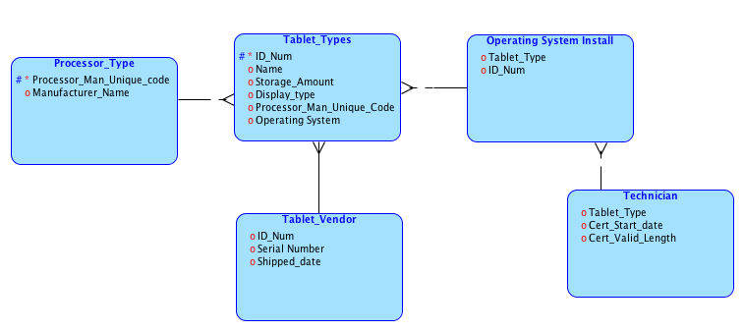

**Part 3**